Situation – Increasing search results by using % the “wildcard” character.
SMART
TIP

Vendor Look-Up (Vendors>Vendor Information>Add/Update>Review Vendors):
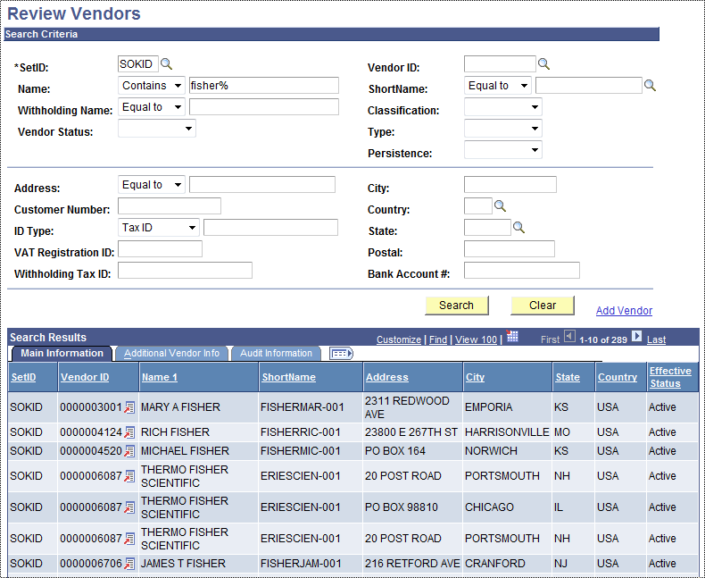
By selecting contains from the drop down and using “Fisher%” 289 results containing the word “fisher” are displayed.

Using 2 wildcard’s in a search:
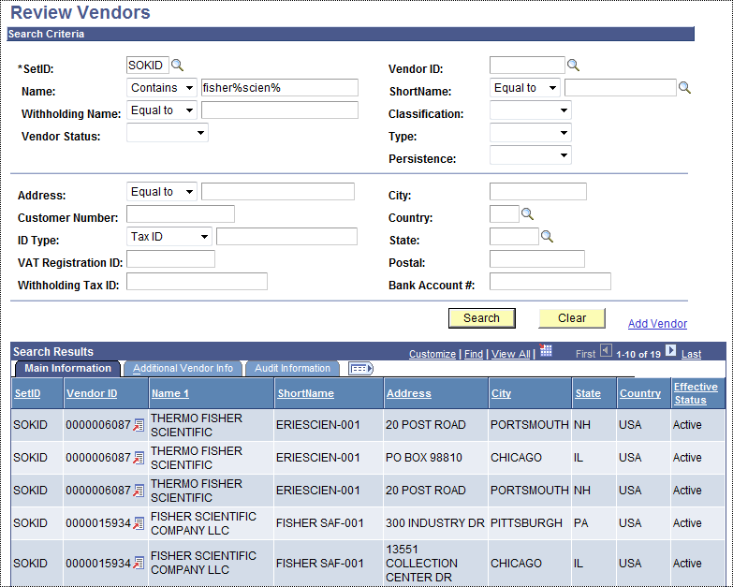
By using “Fisher%Scien%” the results are narrowed down to 19.

There are MANY instances where the wildcard can be helpful when searching in every module!!!

