KPAYGL5C – Step-By-Step Downloading Into Excel Instructions and Tips
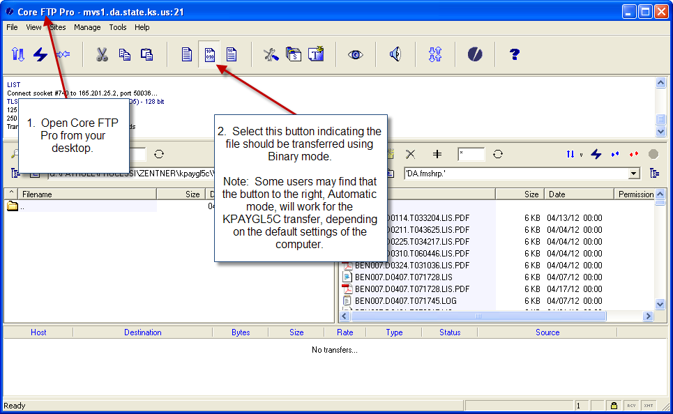
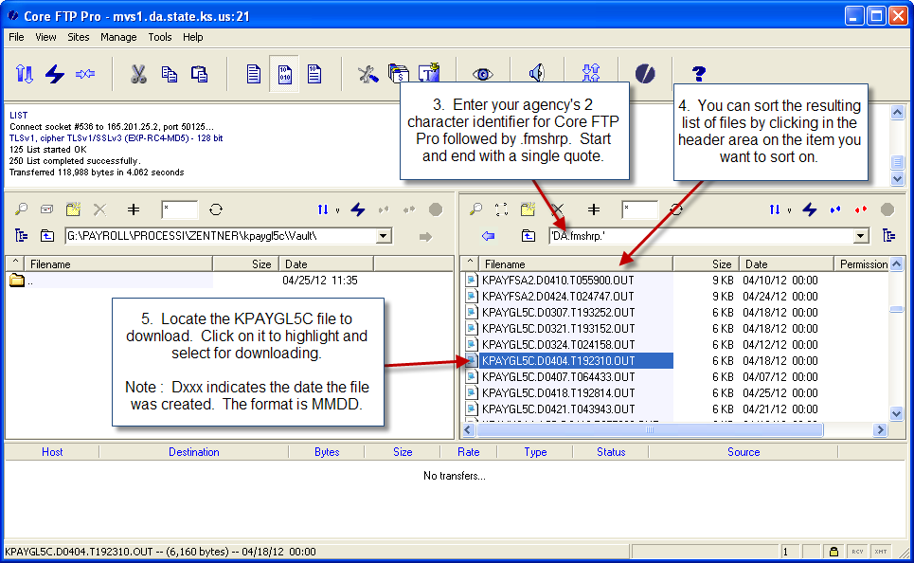
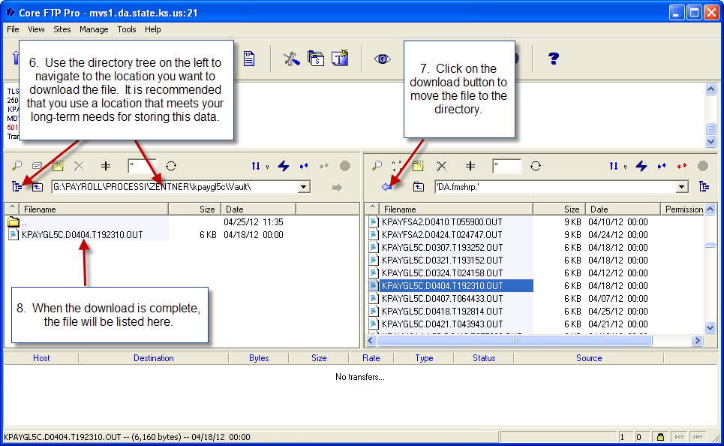
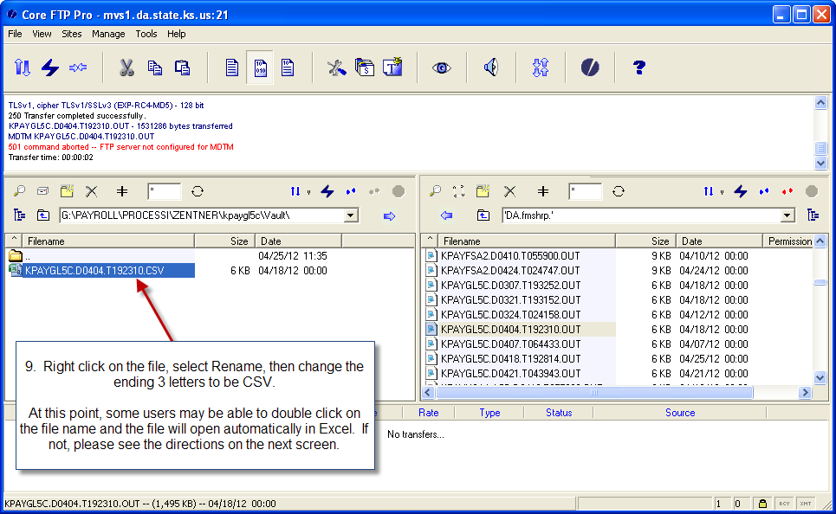
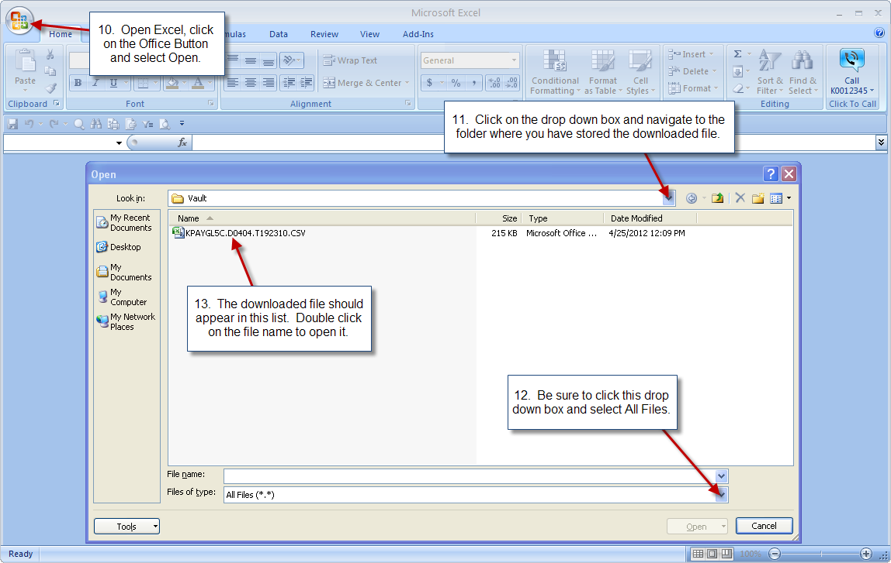
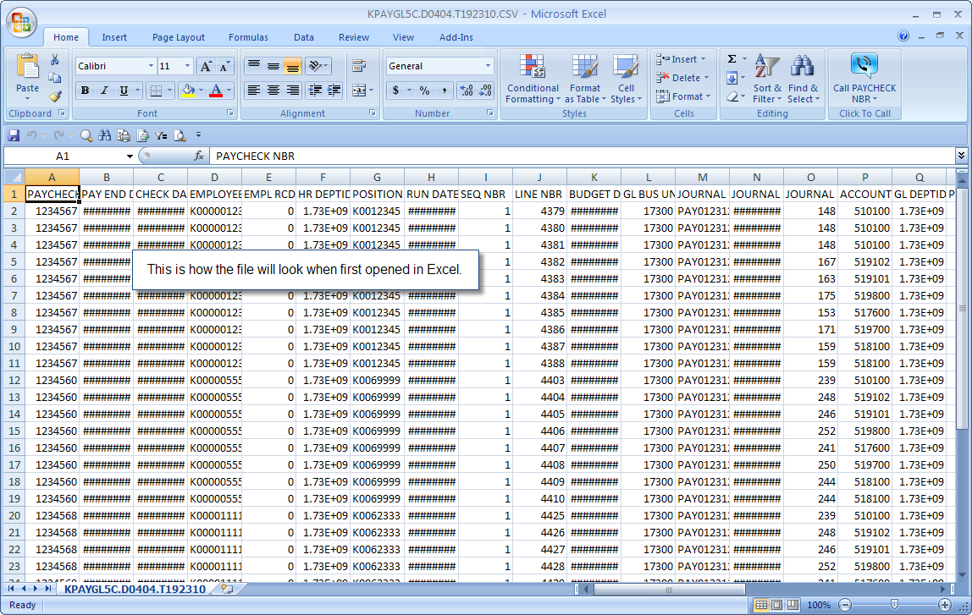
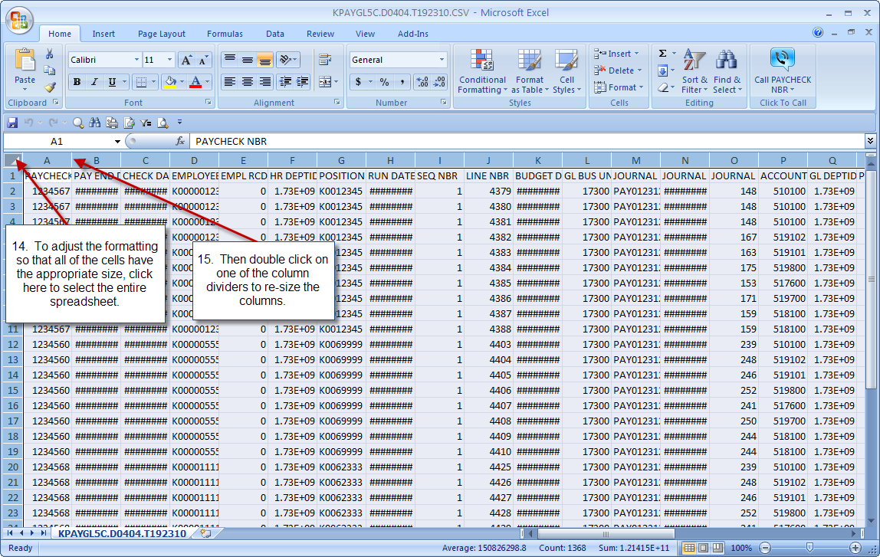
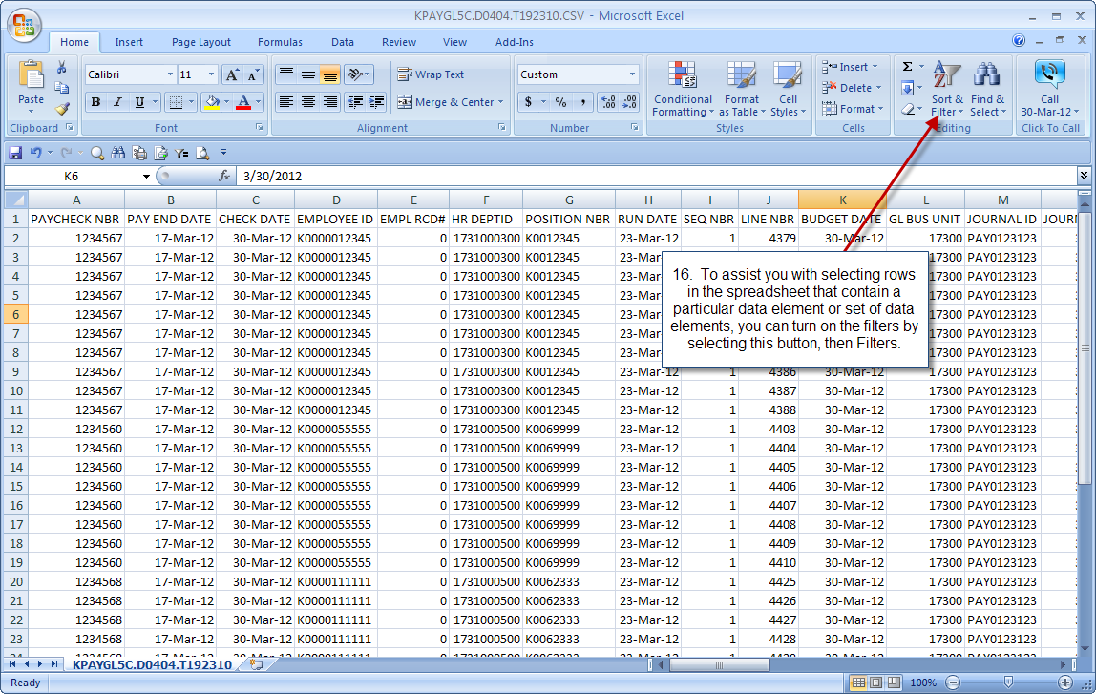
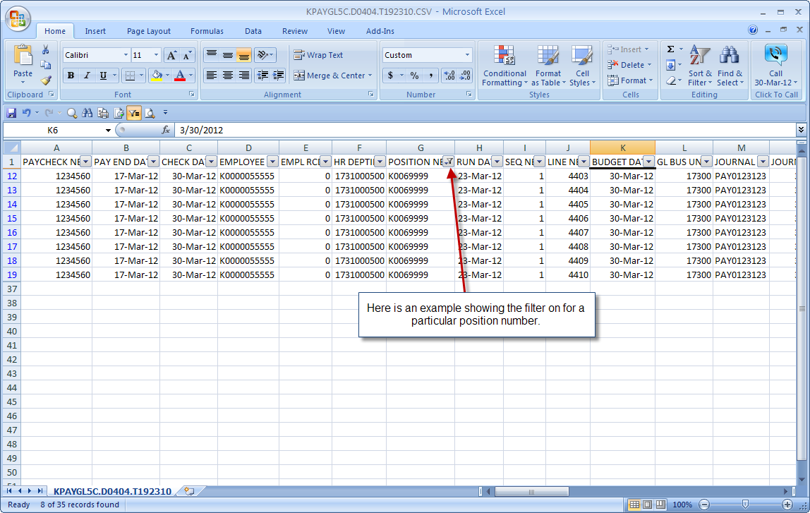
Data elements for KPAYGL5C file:
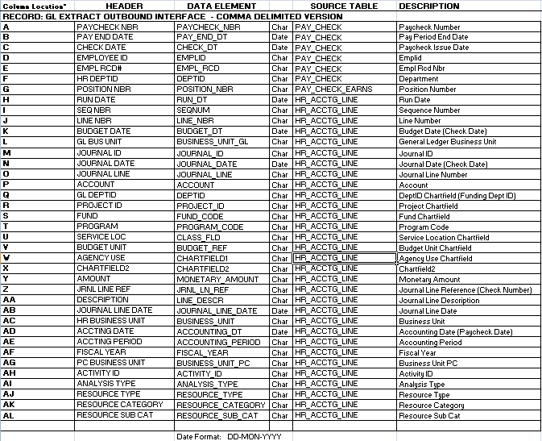
KPAYGL5C Tips and Tricks:
- Download the file within 30 days of the date the file was generated. The file will be deleted from CoreFTP after 30 days.
- Use Outlook to set-up calendar reminders for the days the file needs to be downloaded. Agencies will be billed for special requests to re-generate old pay period files.
- Save the original file in a secure location and create a working copy saved to a different folder. Use the working copy for any manipulation of the data.
- Accumulate the KPAYGL5C files for fiscal year reporting and budgeting.
- Optional: Track all changes (due to journal/budget errors) that are made to payroll journals in SMART and update KPAYGL5C to reflect those changes.
- Optional: Track journals that are processed in SMART to change funding for payroll expenditures, then add rows to KPAYGL5C for those journals.
- There is a query in SMART that can be used to pull all expenditures from the general ledger with accounts in the payroll series 51000-519900. The query includes all payroll journals as well as any other SMART journals using this series of accounts. SMART Query Name: KS_GL_SALARIES_WAGES_EXPENSES
- Consider additional Excel or Access training for staff in order to utilize more sophisticated functions for data manipulation.

